**HIVE TASK**

**HIVE Task-1**

**Q: Write a query to calculate maximum no of shares traded in 2009 industry wise, sector wise and company wise.**

**Sample Data used: nyse_2009 and companylist_noheader**

1. Create table nyse

2. Create table Company

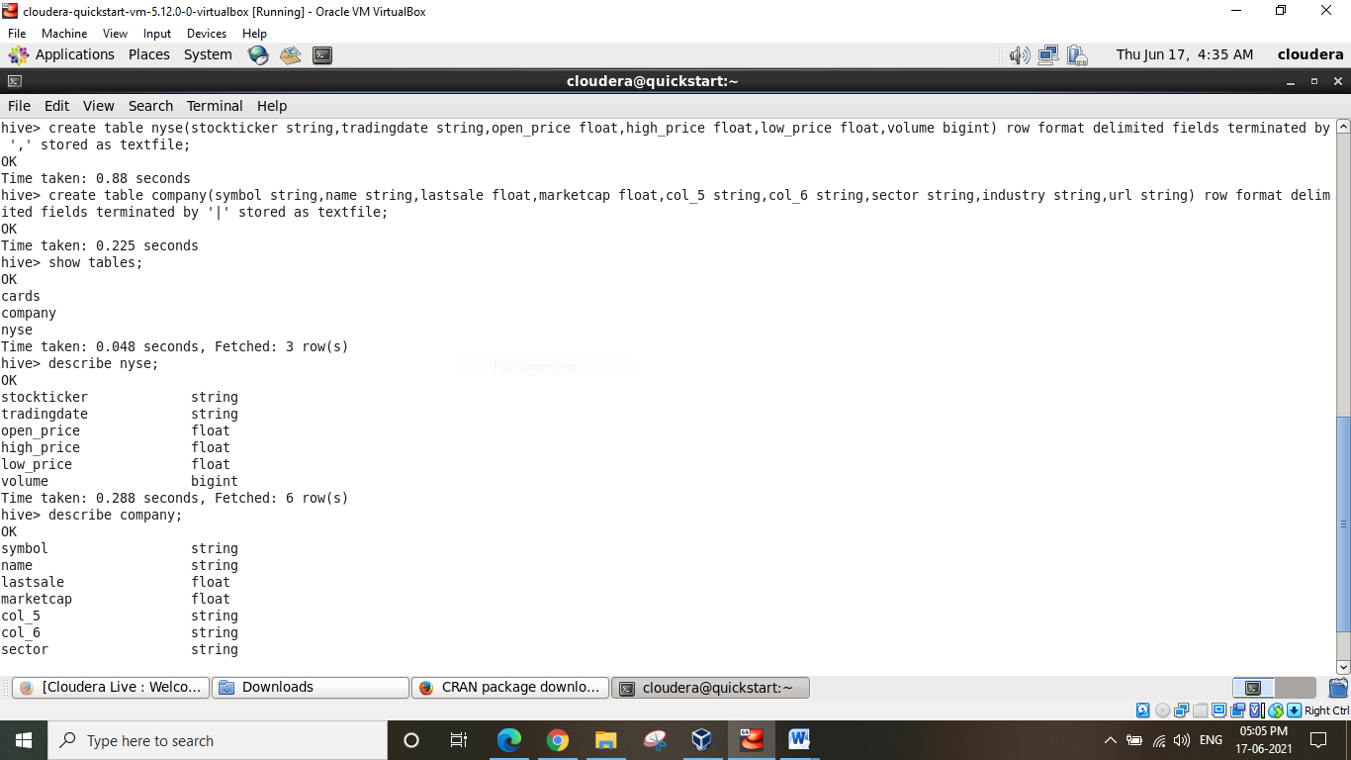

3. load data in nyse and company table.

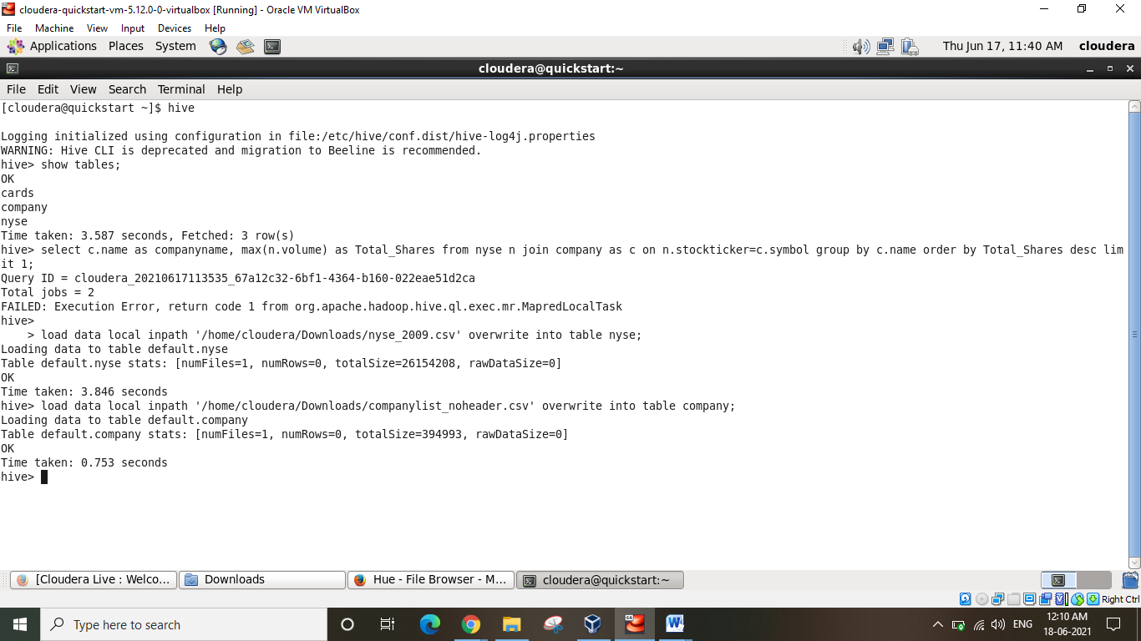

4. Write a query to calculate maximum no of shares traded in 2009 Industry wise.

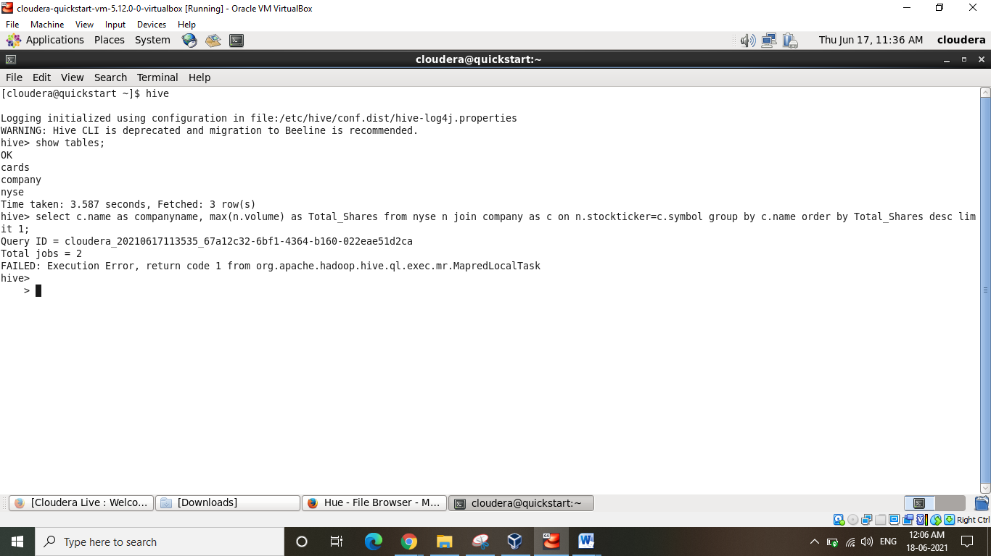

5. Write a query to calculate maximum no of shares traded in 2009 Sector wise.

6. Write a query to calculate maximum no of shares traded in 2009 Company wise